Leadership Dharma
Arjuna’s tool kit
Unlock your potential, unleash the hero within!

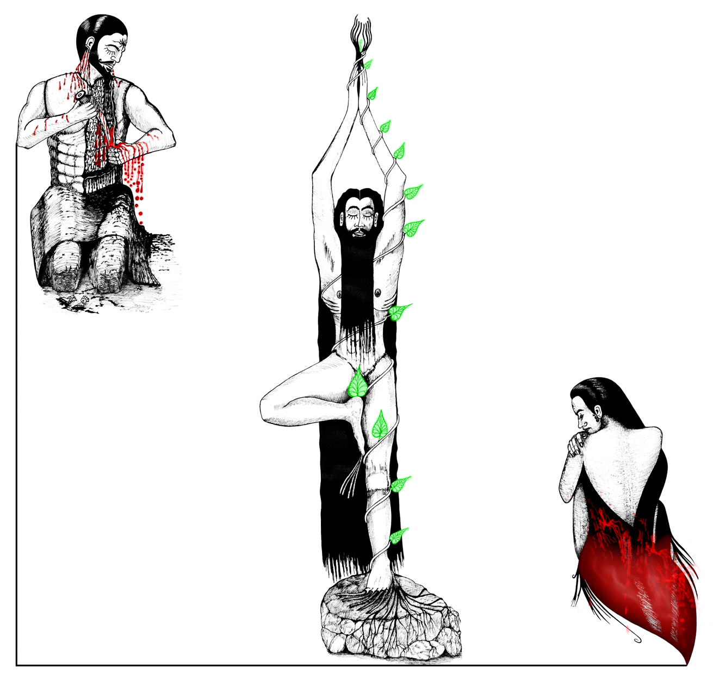

The tool kit comprises of four components
- Interactive Games for personal alignment, role effectiveness, organization synergy and business effectiveness
- The Book: Leadership Dharma, Arjuna the timeless metaphor (with a foreword by Prasad Kaipa)
- A work book for self Development and coaching
- Behavioural profile: Outline of your propensities, enablers and prevalent blocks along your heroic journey.
Through this contemporary retelling of the Myth, Raghu Ananthanarayanan has brought more than a hundred years of consulting experience experience (his own and that of his colleagues) in working with individuals helping transform themselves and their organizations. This interactive Kit recreates the experiential learning methods they have deployed with great success. Entering this quest to become a hero in ones eyes is a gift of a lifetime.

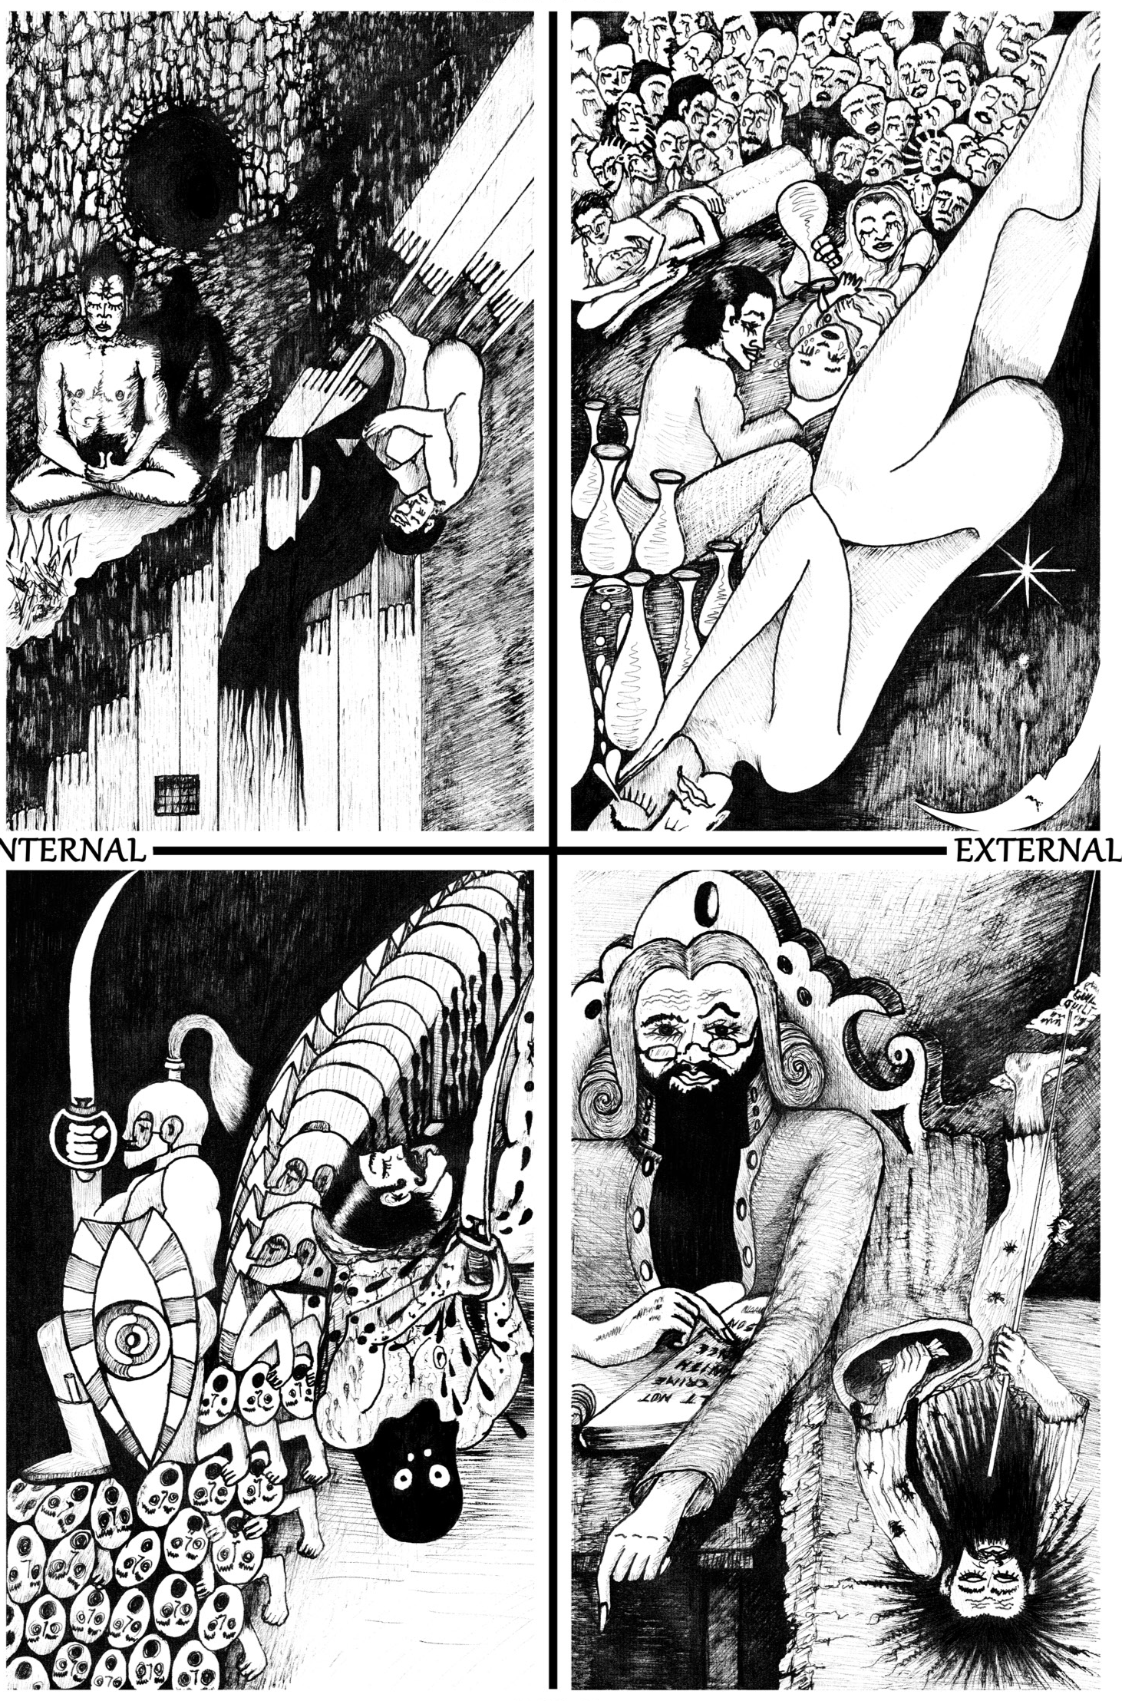

"Are you an Arjuna in a Yudhishtra organization? Are your Bheema employees holding your Nakula organization to ransom?" These analogies from the eternal epic Mahabharatha by Raghu Ananthanarayanan is a thought provoking framework for solving problems of Role effectiveness and culture building. Meaningful for start ups and large organizations alike!

Ranjan is an entrepreneur, a natural Bhīma. His organisation is stagnating. “In doing what I am doing, what am I really doing? How am I part of the problem?” he asks. By using the Mahabharata as a mirror, and through an intense dialogue with his wife Sanam and his friend Prof. Anantha Saptaparni. Ranjan discovers the seeds of the other Paandava heroes that lie within him.

Like Arjuna he embarks on a quest: He identifies his heroic propensities, peers into his shadow self, unleashes his hidden potentials, recovers his sense of purpose, and the eternal spring of energy. Like the bow that must be drawn deeply, and aimed carefully to shoot a true arrow, Ranjan emerges with new reserves of strength connected to the wisdom that lies within him anchored in an expanded capacity to meet challenges and play effective roles.

Ranjan discovers how to “be the solution” and lead the organization. He learns how to help each of his teammates do the same, and together they renew and regenerate themselves and their organization.

Who am I?
Where am I?
Why am I here?
We guarantee that you will answer these three quintessential questions that hold the key to Heroic action through this learning Kit.

5

“By forcing us into the spotlight, making us communicate in unusual and uncomfortable ways, or encouraging us to take giant lateral leaps in thinking, games can immerse us in hilarity, strengthen our connections with friends and family, and significantly stretch our minds”
What Board Games Can Teach Business
Andrew Innes
HBR- Jan 201

